# 24-10-2021

# ABHINAV RANJAN

# RA1911003010003

# CSE A1 SECTION

# SRMIST , KTR

# CN LAB EXP 14 -HDLC configuration

Introduction

HDLC is a data link protocol used on synchronous serial data links. Because the standardized HDLC cannot support multiple protocols on a single link (lack of a mechanism to indicate which protocol is carried), Cisco developed a proprietary version of HDLC, called HDLC, with a proprietary field acting as a protocol field. This field makes it possible for a single serial link to accommodate multiple network-layer protocols.

Cisco’s HDLC is a point-to-point protocol that can only be used on serial links or leased lines between two Cisco devices. [PPP](https://www.packettracernetwork.com/labs/lab12-ppp.html) has to be used when communicating with non-Cisco devices. HDLC is the default encapsulation on serial links in a Cisco router. However, to change the encapsulation back to HDLC from PPP, use the following command from interface configuration mode:

Router(config-if)#encapsulation hdlc

With a back-to-back serial connection, the ISR router connected to the **DCE** end of the serial cable provides the clock signal for the serial link. This clock is received by the **DTE** device. The **clock rate** command in the interface configuration mode enables the router at the DCE end of the cable to provide the clock signal for the serial link. The default clock rate is 64000.

Network diagram

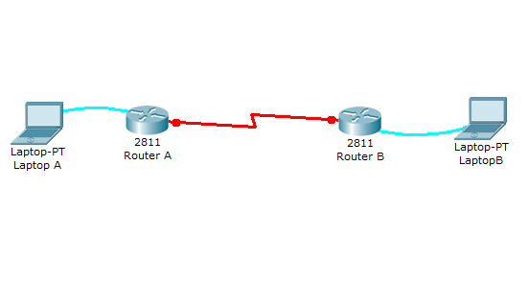

This lab will test your ability to configure HDLC back to back connection on a serial link between two Cisco ISR routers in Packet Tracer 8.0 . Practicing this labs will you to get ready for the CCNA certification exam simulation questions.

1. Use the connected laptops to find the DCE and DTE routers. You can connect to the routers using CLI.

2. Configure the routers with the following parameters :

- Clock : 250000

- HDLC link between the routers

- DCE router IP : 192.168.10.5/30

- DTE router IP : 192.168.10.6/30

3. Check IP connectivity between the two routers using the ping command.

**1. Use the connected laptops to find the DCE and DTE routers**

The show controllers <serial interface> command is used to determine which side of the cable is the DCE side.

In this example, Router-A is the DTE side, and Router-B the DCE side (DCE V.35, clock rate set).

Router-A#show controllers serial 0/0/0

Interface Serial0/0/0

Hardware is PowerQUICC MPC860

DTE V.35 TX and RX clocks detected

Router-B#show controllers serial 0/0/0

Interface Serial0/0/0

Hardware is PowerQUICC MPC860

DCE V.35, clock rate 2000000

**2. Configure the routers with the following parameters**

Router-B beeing the DCE, clock rate has to be configured on Router-B serial 0/0/0 interface

Router-B(config)#interface serial 0/0/0

Router-B(config-if)#clock rate 250000

Then, configure HDLC encapsulation and IP address on Router-B serial 0/0/0 interface. The **encapsulation hdlc** configures HDLC protocol on the serial interface.

Router-B beeing the DCE side of the serial link, the 192.168.1.5/30 IP address is configured on Router-B serial 0/0/0 interface. Don't forget to enable the interface with a **no shutdown** command.

Router-B(config)#interface serial 0/0/0

Router-B(config-if)#encapsulation hdlc

Router-B(config-if)#ip address 192.168.10.5 255.255.255.252

Router-B(config-if)#no shutdown

The show interfaces serial 0/0/0 confirms that HDLC encapsulation is enabled on the interface : *Encapsulation HDLC, loopback not set, keepalive set (10 sec)*

Router-B#show interfaces serial 0/0/0

Serial0/0/0 is up, line protocol is up (connected)

Hardware is HD64570

Internet address is 192.168.10.5/30

MTU 1500 bytes, BW 1544 Kbit, DLY 20000 usec,

reliability 255/255, txload 1/255, rxload 1/255

Encapsulation HDLC, loopback not set, keepalive set (10 sec)

Last input never, output never, output hang never

[...]

Finally, configure HDLC encapsulation and IP address on Router-A serial 0/0/0 interface. The link becomes up as both routers are correctly configured.

Router-A(config)#interface serial 0/0/0

Router-A(config-if)#encapsulation hdlc

Router-A(config-if)#ip address 192.168.10.6 255.255.255.252

Router-A(config-if)#no shutdown

%LINK-5-CHANGED: Interface Serial0/0/0, changed state to up

**3. Check IP connectivity between the two routers using the ping command.**

Issue a ping from Router-A to Router-B to test network connectivity between the two routers.

Router-A#ping 192.168.10.5

Type escape sequence to abort.

Sending 5, 100-byte ICMP Echos to 192.168.10.5, timeout is 2 seconds:

!!!!!

Success rate is 100 percent (5/5), round-trip min/avg/max = 3/3/4 ms

Screenshots:

